Book

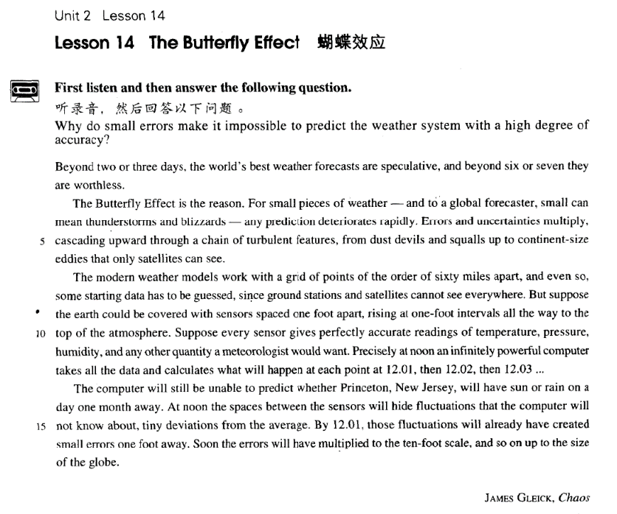

课文

Beyond two or three days, the world's best weather forecasts are speculative, and beyond six or seven they are worthless.

世界上最好的两三天以上的天气预报具有很强的猜测性，如果超过六七天，天气预报就没有了任何价值。

The Butterfly Effect is the reason.

原因是蝴蝶效应。

For small pieces of weather -- and to a global forecaster, small can mean thunderstorms and blizzards -- any prediction deteriorates rapidly.

对于小片的恶劣天气 -- 对一个全球性的气象预报员来说，“小”可以意味着雷暴雨和暴风雪 -- 任何预测的质量会很快下降。

Errors and uncertainties multiply, cascading upward through a chain of turbulent features, from dust devils and squalls up to continent-size eddies that only satellites can see.

错误和不可靠性上升，接踵而来的是一系列湍流的徵状，从小尘暴和暴风发展到只有卫星上可以看到的席卷整块大陆的旋涡。

The modern weather models work with a grid of points of the order of 60 miles apart,

现代气象模型以一个坐标图来显示，图中每个点大约是间隔60英里。

and even so, some starting data has to be guessed, since ground stations and satellites cannot see everywhere.

既使是这样，有些开始时的资料也不得不依靠推测，因为地面工作站和卫星不可能看到地球上的每一个地方。

But suppose the earth could be covered with sensors spaced one foot apart, rising at one-foot intervals all the way to the top of the atmosphere.

假设地球上可以布满传感器，每个相隔1英尺，并按1英尺的间隔从地面一直排列到大气层的顶端。

Suppose every sensor gives perfectly accurate readings of temperature, pressure, humidity, and any other quantity a meteorologist would want.

再假定每个传感器都极极端准确地读出了温度、气压、温度和气象学家需要的任何其他数据。

Precisely at noon an infinitely powerful computer takes all the data and calculates what will happen at each point at 12.01, then 12.02, then 12.03...

在正午时分，一个功能巨大的计算机搜集了所有的资料，并算出在每一个点上12：01、12：02、12：03时可能出现的情况。

The computer will still be unable to predict whether Princeton, New Jersey, will have sun or rain on a day one month away.

计算机无法推断出1个月以后的某一天，新泽西州的普林斯顿究竟是晴天还是雨天。

At noon the spaces between the sensors will hide fluctuations that the computer will not know about, tiny deviations from the average.

正午时分，传感器之间的距离会掩盖计算机无法知道的波动、任何偏平均值的变化。

By 12.01, those fluctuations will already have created small errors one foot away.

到12：01时，那些波动就已经会在1英尺远的地方造成偏差。

Soon the errors will have multiplied to the ten-foot scale, and so on up to the size of the globe.

很快这种偏差会增加到尺10英的范围，如此等等，一直到全球的范围。

词汇讲解

Lesson 14 The butterfly effect forecast

['fɔ:kɑ:st] ['fɔ:rkæst]

n. & v. 预测，预报

forecast v. & n. to publicly say what will happen in the future with the weather or the economic or political situation, esp. when you have special or technical knowledge

weather forecast

the company’s annual sales forecast Rain has been forecast for tomorrow.

The Federal Reserve Bank forecasts the economy will grow 8% this year. predict / foretell

He predicted / foretold that the improvement will continue. Timely snow foretells a bumper harvest.

forebode

Black clouds forebode a storm. prophesy

Jesus prophesied that one of his disciples would betray him. speculative

['spekjələtɪv]

adj. 推测的；投机的

speculative adj. based on guessing, not on information or facts His conclusions are purely speculative.

speculative investments speculate v. 1. 猜测

We can only speculate *on* the reasons for his sudden resignation.

speculate v. 2. to buy goods, property, shares etc., hoping that you will make a large profit when you sell them 投机

speculate *in* stocks

speculation conjecture

guesswork / guess work

property speculation blizzard ['blɪzəd]

n. 特大暴风雪

blizzard n. severe snowstorm thunderstorm snowstorm

windstorm sandstorm

squall dust devil

cyclone hurricane

typhoon tornado

deteriorate [dɪ'tɪəriəreɪt]

v. 变糟，恶化

Alan’s health has deteriorated. America’s deteriorating economy deteriorate into …

The discussion deteriorated into a bitter quarrel. degenerate

Our relationship has degenerated over the years. degenerate into …

Don’t allow your comments degenerated into a personal attack. worsen

The weather worsened during the night. get worse

go from bad to worse go downhill

Moving in together was a mistake, and our relationship rapidly went downhill.

turbulent ['tɜ:bjələnt]

adj. 汹涌而不稳定的；动荡的

turbulent adj. air or water moving violently and unevenly turbulent waves

the turbulent times of the French Revolution turbulence

political turbulence social turbulence “turb” = disturb 搅乱

turbid turbine perturb

Mother was perturbed by my illness. imperturbable

humidity [hju:'mɪdəti]

n. 湿度

humid

humid air / atmosphere

humid summer nights wet

Her hands were wet. a wet sponge

damp / moist

Bring me a moist towel. a cold, damp collar meteorologist [7mi:tiə'rɒlədʒɪst]

n. 气象学家

meteorologist meteorology meteor shooting / falling star meteor shower meteor swarm

meteorite asteroid

deviation [7di:vi'eɪʃn]

n. 偏差，偏离常规

deviation n. a difference from what is expected or acceptable Left deviation

Right deviation sexual deviation

Any deviation from the party's faith is seen as betrayal.

At noon the spaces between the sensors will hide fluctuations that the computer will not know about, tiny deviations from the average.

deviate from …

deviate from one’s plan / principles

deviant

a sexual deviant

“de” =away from + “vi(a)”=道路 + ate（动词字根） via

go from London to Washington via New York viable

a viable proposal economically viable obviate

The new treatment obviates the need for surgery. a social butterfly

have butterflies (in one’s stomach)

It was the morning of the World Cup Final and most of the players had

butterflies (in their stomach). chaos theory

Small changes in initial conditions can lead to large-scale and unpredictable variation in the future state of the system.

A frequent metaphor for one aspect of chaos theory is the Butterfly Effect: butterflies flapping their wings in the Amazon affect the weather in Chicago.

beyond prep. after …; later than … Exceeding two or three days, …

… are based on speculation / conjecture.

… are based on guesswork / guess work.

… they are valueless

… they are useless

… they are of no earthly use.

… they are totally useless.

The Butterfly Effect is the reason for / behind it. The Butterfly Effect accounts for it. √

The Butterfly Effect underlies it. √ The reason is the Butterfly Effect. √

The reason lies in the Butterfly Effect. √

The reason is because of the Butterfly Effect. X

For small pieces of weather — and to a global forecaster, small can mean

thunderstorms and blizzards — any prediction deteriorates rapidly. mean v. be likely to result in …

The merger will mean the eventual closure of the company’s Shanghai Office.

… any prediction gets worse / degenerates / becomes inaccurate rapidly. Errors and uncertainties multiply, cascading upward through a chain of turbulent features, *from dust devils and squalls up to continent-size eddies that only satellites can see*.

multiply v. to increase by a large amount or number, or to make sth. do this （使）大幅增加

Within the last 10 years, both sales and profits have multiplied.

Smoking multiplies the risk of heart attacks. snowball

Unemployment snowballed at the beginning of 1980s. proliferate

Small businesses have proliferated in the last ten years. mushroom

Trade between the two countries has mushroomed. explode

China’s population exploded after 1949. population explosion

a chain of … a series of …

a train of … a string of … a succession of …

a progression of … feature n. characteristic from A to B

from A up to B

The modern weather models work with a grid of points *of the order*

*of 60 miles apart*, and even so, some starting data has to be guessed, since ground stations and satellites cannot see everywhere.

work v. (of a machine, device, etc) function; operate （指机器、设备等）

运作，运转

This machine works by electricity. The delete key doesn't work.

grid n. a pattern of straight lines that cross each other to form squares streets laid out on a grid pattern

of / in / on the order of … = approximately

The house cost him something on / in / of the order of $200,000.

The house cost him something in the neighborhood / vicinity of

$200,000.

The house cost him approximately $200,000. starting adj. beginning

initial

at the initial stage / phase

incipient incipient tumor

the incipient light of day opening

his opening remarks

the opening scene of the movie preliminary

a preliminary exam / contest

But suppose the earth could be covered with sensors spaced one foot

apart, *rising at one-foot intervals all the way to the top of the atmosphere*. space v. 将……均匀隔开

Space your workouts two days apart to avoid sore muscles.

Bean plants should be spaced three inches apart. interval n. 1.（两事件中的）间隔时间

…, and by measuring the time interval between the taps and the receipt of

the echoes the depth of the sea at that point can be calculated. interval n. 2.（物体之间的）间隔空间

They planted trees in the intervals between the houses.

all the way 一 直 …… He ran all the way home.

Eventually the turtle has been butted all the way down to the floor of the

tank.

Suppose every sensor gives perfectly accurate readings of temperature, pressure, humidity, and any other quantity a meteorologist would want. take the meter reading

read the meter

*Precisely at noon* an infinitely powerful computer takes all the data and

calculates what will happen at each point *at 12.01, then 12.02, then*

*12.03...*

at high noon

at 12 o’clock sharp

at punctually 12 o’clock

infinite The universe is infinite. finite Human knowledge is finite. infinitive

definite

indefinite an indefinite answer definitive a definitive verdict work out figure out

compute reckon

The inflation is reckoned to be 10%.

At noon the spaces between the sensors will hide fluctuations that the computer will not know about, *tiny deviations from the average*.

… will have snowballed to …

… will have proliferated to …

… will have rocketed to …

… will have soared to … on a small scale

on a limited scale

on a large / grand scale

on a / an colossal / enormous / gigantic scale on a national / nationwide scale

on a / an global / international / world / worldwide scale and so on

and so forth etc. (et cetera) and the like and what not global size global scale

international / world / worldwide scale